ANNUAL FATHER’S DAY FISHING DERBY
A catch and release fishing derby for boys and girls ages 5 to 15 years in four age categories.
SUNDAY, JUNE 18, 2023
Peace Valley Park Pavilion 1 - Angler's Pier • Doylestown, PA

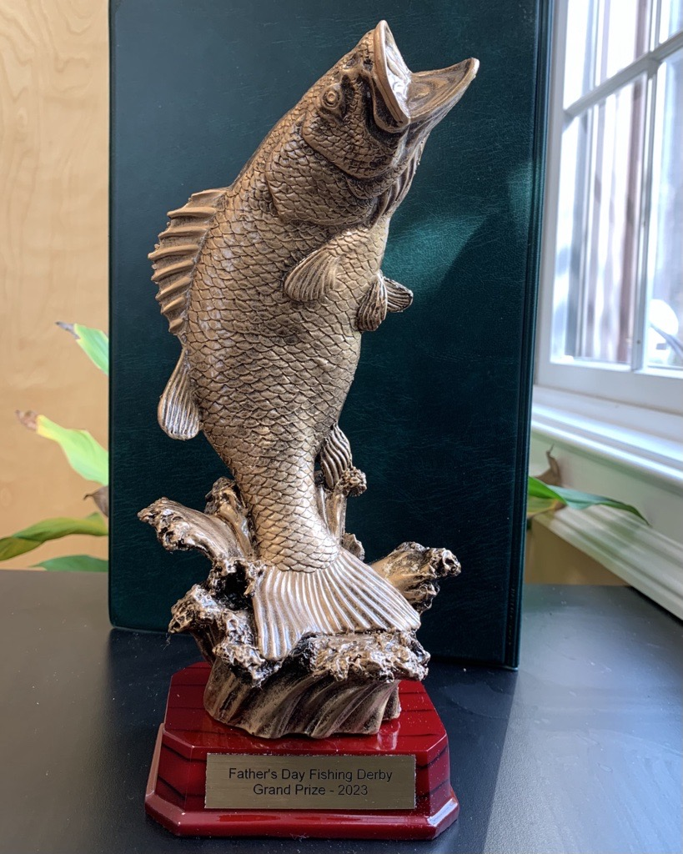

- Grab the tickets, 2: Catch the fish, 3: Win some prizes, GO! Prizes for age groups and largest fish
For more information see the highlights section of our website. See you there!

